**Sky Blaze – Protect your city from the terrible meteors**

São Paulo, Brazil, 2016 – Cruel Byte is pleased to announce the release of

“Sky Blaze” to the mobile platforms. The game is free to play and available to download from Google Play and App Store.

In “Sky Blaze” you are the last hope of your civilization! Since everyone fled away, you’re the commander in charge of the most powerful missile launcher on the Earth (luckly) in order to destroy all meteors before they reach our planet.

[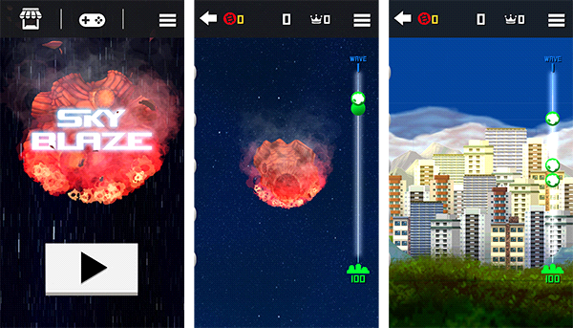](http://bit.ly/2bileYK)

(click or tap the image to watch the trailer)

**Instructions:**

-Wave based game with progressive difficulty curve

-Hit the meteor by tapping it

-The meter at right shows distance and the meteor’s estimated time arrival

-In-game coins for you to buy upgrades or tactical power-ups

“Sky Blaze” was designed in partnership with Messier game studio, and developed by Cruel Byte with the Unity engine and its powerful 2D tools. It uses lots of particles systems and effects that really takes you into the game!

The game also features infinite waves of meteors, with progressive difficult curve. You can buy lots of upgrades for you and your city, that makes the job a lot easier, all with in-game coins.

**Sky Blaze download links**

[Android](concept) / [iOS](http://apple.co/2aMN4JH) / [Press Release](https://drive.google.com/open?id=0B4EC3eqsKdvLNWpnT1lhR2pBYVU)

**About Cruel Byte**

Cruel Byte is a game development studio focused on mobile, PC and VR industries, as well as other entertainment platforms, bringing to players the greatest cruel games. The company is behind known titles such as “Veloz”, “Dead Zombie Land”, and “Dark Ascent” for mobile and PC platforms.

**About Messier Games & Animations**

Messier Games & Animations is a Brazilian game developer, thanks to several established national partnerships and internationally, produces copyright and on-demand games and gamification processes using all kinds of digital experience, such as Augmented Reality, Virtual Reality and even Holography.

**Web site:** [www.cruelbyte.com](http://www.cruelbyte.com)

**Email:** [contact@cruelbyte.com](mailto:contact@cruelbyte.com)