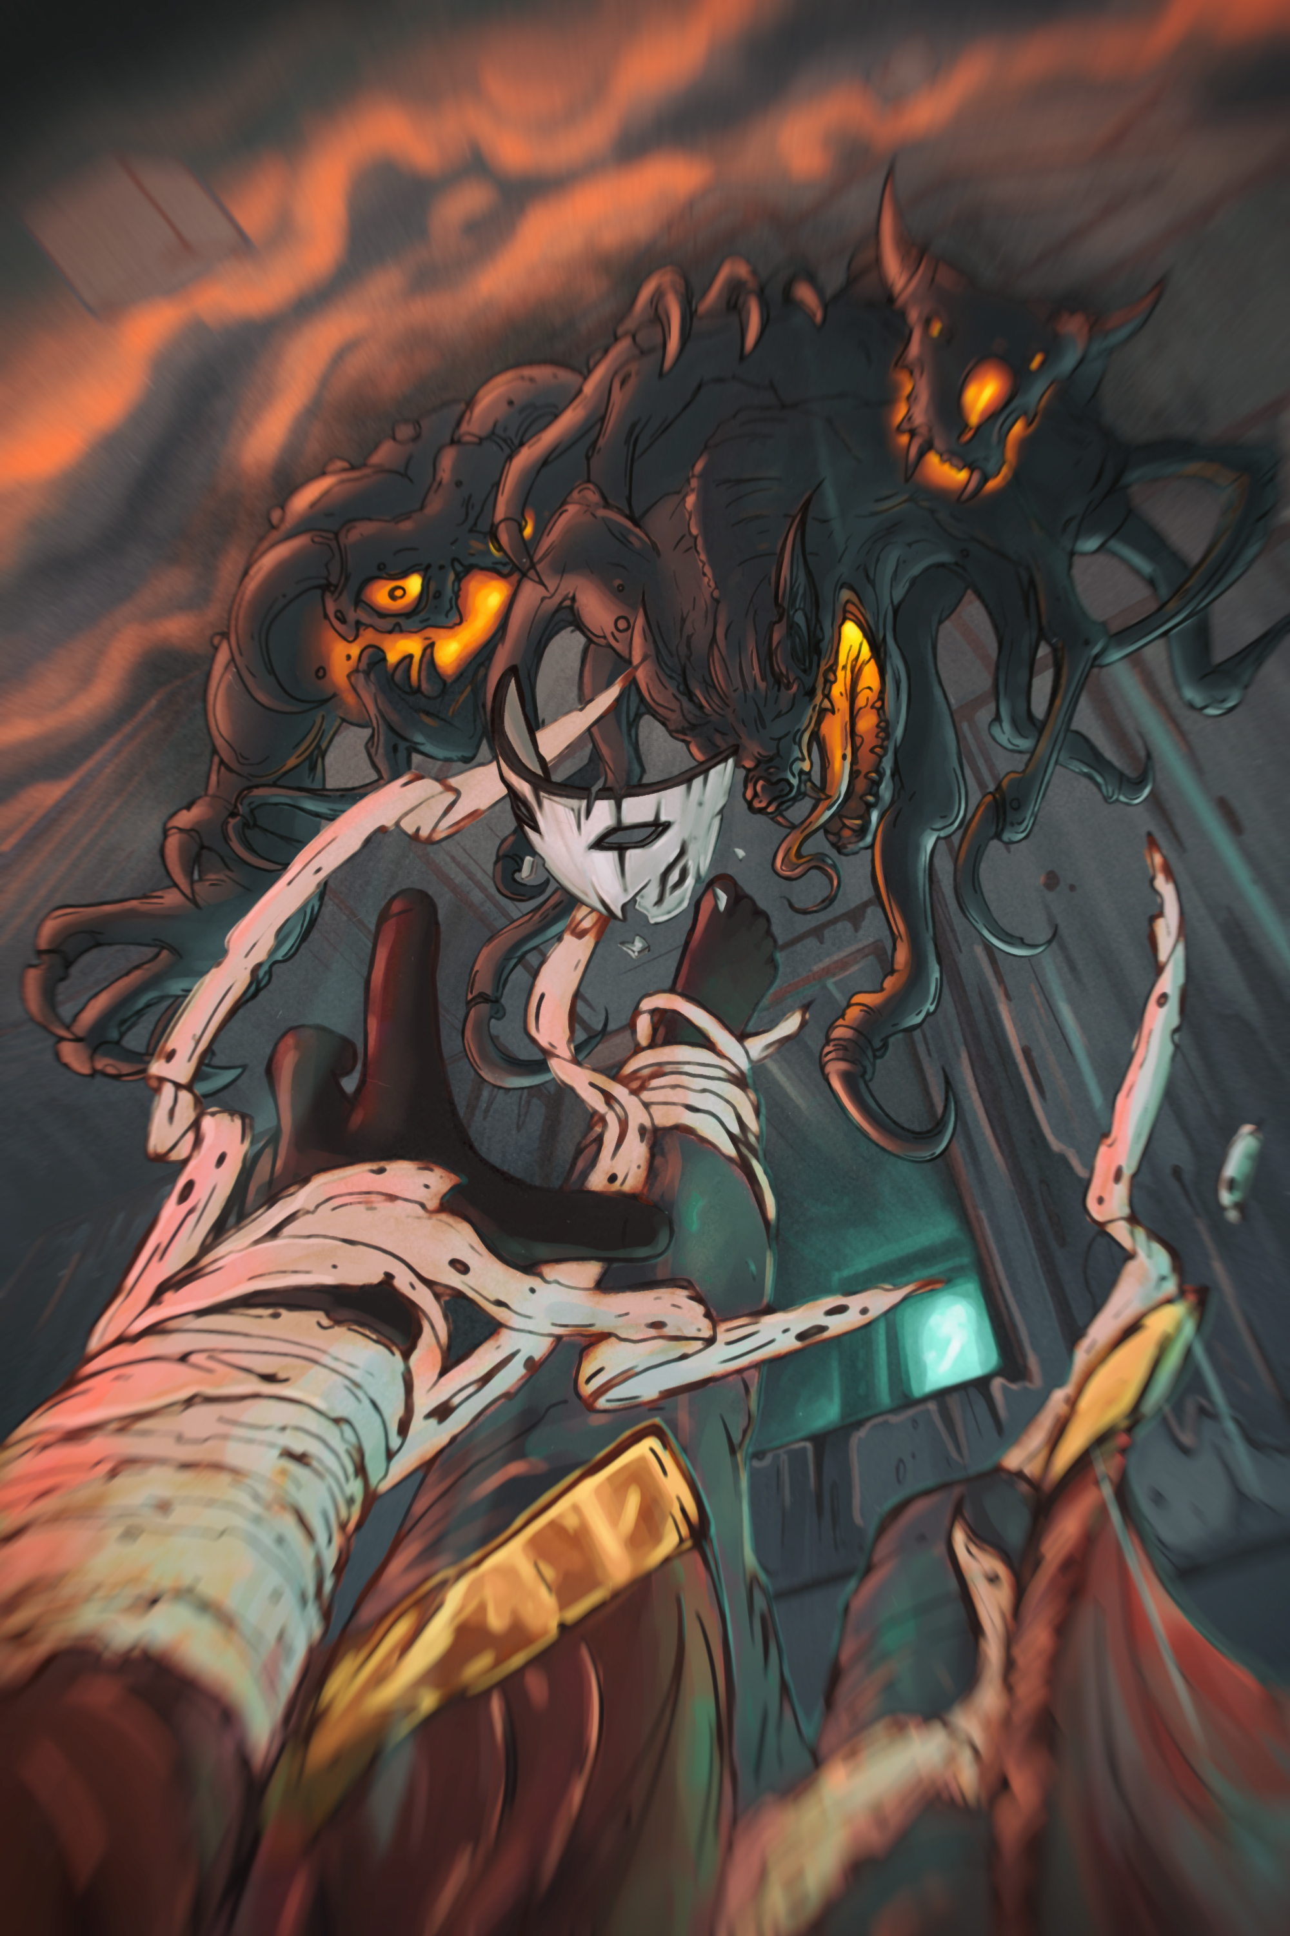General information:

* Name of the game: Mortido
* Team: "Corner-Studio"
* The date of entrance on Steam Greenlight: autumn 2015
* Genre: Adventure (Platformer/Adventure)
* Platforms: PC, Mac, Linux
* Interface language: Russian, English
* Language voice: Russian, English

Operating System:

* Windows 7(8) 64-bit/Mac OS X 10.9.2
* Processor: Quad-core Intel or AMD, 2.5 GHz or faster
* Memory: 4 GB RAM
* Video Card/DirectX Version: DirectX 11 compatible graphics card.

Mortido – the game, which move you in the incredibly colourful and fantastic world. You will soak into the story of people, who has the life with easy and not always correct decisions… The story about 40 days long path of the human soul after death. The central character will periodically come back in the world of alive (using FlashBacks), knowing every time more and more about his past and gradually recall it.

With every step you will know how and WHY the character was in such situation.

The mass of strong emotions reserved for you. So deeper you will go into the created Universe more you will notice the features of a game:

* Full support of gamepad
* Great number of different mysteries and puzzles
* Several worlds with their own unique style
* Interesting and mysterious destinies of characters
* Beautiful graphics, made in the anime style
* More than 100 different animations of a characters
* Complete freedom of actions
* Unique system of skills development
* Sharpen of a character’s abilities just in the game process. (with every new perfect performance of acrobatic elements character is doing it better and better).

You can find more details here:

Fecebook: <https://www.facebook.com/groups/mortido/>

Twitter: <https://twitter.com/CSmortido>

Vkontakte: <https://vk.com/csmortido>