

**‘Zombie Company Crusade’ Available Free In The Apple App Store**

**Defend the world against the zombie scourge with full troop controls and battle against your friends and foes in Arena Mode.**

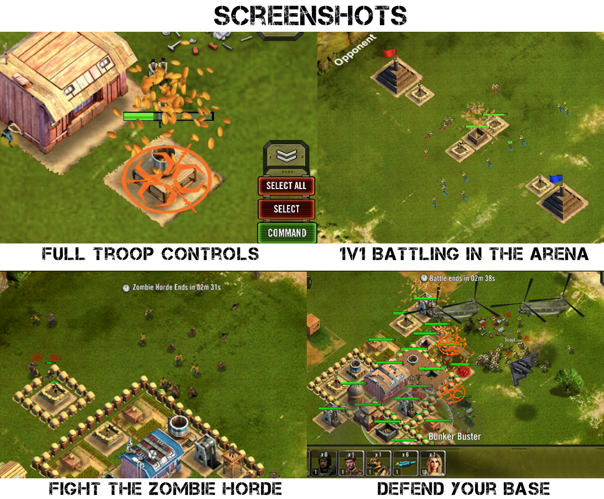Fort Collins, CO- April 1, 2015- Released September 1st 2015, Zombie Company Crusade is a new gaming project developed by a former United States Marine Scout Sniper who while working anti-piracy on ships off the coast of Africa was struck with inspiration to build his own video game. With Zombie Company Crusade, Thad David aims to change the way we play and interact with other gamers on our mobile devices. It is designed to optimize single and multi-player gaming and adds the chaos, excitement and thrill that only marauding zombie hordes can bring to traditional game play.

Who doesn’t love a good zombie horde wreaking some serious havoc!

Zombie Company Crusade adds those in-demand, player-driven features, such as extensive troops controls and manipulation, company battles and targeted friend-to-friend battling for a well-rounded, engaging experience that keeps players immersed in their post-apocalyptic zombie-ridden world. This game is a departure from the traditional cartoon-esque approach most mobile games have taken with their graphics and delivers realistic and dynamic art. Creator of Zombie Company Crusade, Thad David, believes that “This game will fix what is wrong with RTS mobile gaming by giving the players control, not the game, and will bring the mobile gaming industry to the next level.”

This is not your average save-the-world game. This is a save-the-world game for serious game lovers looking to take their mobile experience to the next level.

Game Link to App Store: [https://itunes.apple.com/us/app/zombie-company-crusade/id910929302?ls=1&mt=8](https://itunes.apple.com/us/app/zombie-company-crusade/id910929302?ls=1&mt=8" \t "_blank)

Provided is the game trailer as well as a tutorial walk-through by game-creator Thad David:

Trailer: <https://www.youtube.com/watch?v=GMyfr7Vf2Sg>

Walk-through: <https://www.youtube.com/watch?v=gkGfbF05g8Y>

Related Articles:

Venture Beat: http://venturebeat.com/2015/09/17/how-thad-david-went-from-being-a-video-game-worthy-badass-to-a-video-game-developer/

App Picker: <http://www.apppicker.com/reviews/26150/zombie-company-crusade-app-review>

Zombie Company Crusade is free to play. Players may choose to use in-game purchases that are available at their discretion.

For more information and graphics please visit our website at [www.zombiecompanycrusade.com](http://www.zombiecompanycrusade.com).

Zombie Company Crusade will bring mobile gamers full control and accessibility for their ideal gaming experience.

###

If you would like further information on Zombie Company Crusade or would like to schedule and interview, please contact:

Thad David

Phone: (504)-450-2826

Email: [h.thad.david@gmail.com](mailto:h.thad.david@gmail.com)

Twitter: @ThadDavid

Facebook: www.facebook.com/H.Thad.David