

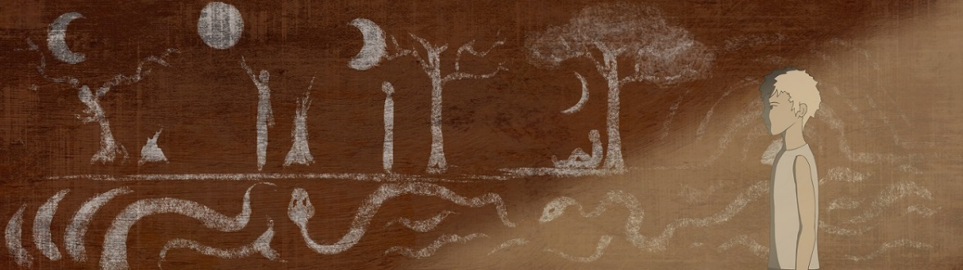

**The hand-drawn graphic adventure Saucer-Like available now on Steam.**

* **Saucer-Like** is a Point & Click twilight graphic adventure developed by the independent publishing house **Fosfatina** and edited by the indie Publisher **Tizona Interactive**.
* This videogame contains more than 40 hand-drawn backgrounds including over 7 minutes of outstanding 2D anime style animations.
* The price of this videogame is $/€5.99 with a 10% launching discount.

**Madrid, 5th of April, 2017**.The graphic adventure Saucer-Like, developed by the Galician publishing house Fosfatina and edited by the Publisher Tizona Interactive, **lands today on the digital platform of Steam**. Saucer-Like allows players to travel through many high-quality scenarios set in the Japanese Middle Ages and **entirely crafted by hand**.

The protagonist is **Yanagi**, a young member of the clan of silent guardians and forest dwellers. He wakes up one morning knowing that he has to **face the most momentous day of his life**. On the day the action takes place, all members of the town must **carry out a long anticipated ritual** that has been handed down from generation to generation waiting for this moment. Yanagi **will have to take an irrevocable decision** that could unite him or separate him from his clan forever. Once the ritual begins, there will be no going back.

Saucer-Like is developed under the Unity game engine counting on the classic Point & Click mechanics. This intriguing and captivating story is framed by **more than 40 hand-drawn scenarios** wrapped in a twilight atmosphere. It also accommodates a minimalist, yet inviting script strengthened by an original, beautiful, and emotional **instrumental soundtrack**.

Saucer-Like is more than just a videogame. It is an animist fable; a reflection on the role of the individual in society. “In Saucer-Like **we aim at involving the user in the story** while, by means of audio visual resources, he or she is entangled in the particular atmosphere of this universe, which is **halfway between the dark fantasy and Michael Ende’s stories twilight surrealism**” explains Fosfatina.

This Fosfatina’s title **is already available on Steam for €5.99** (with a 10% launching discount). Texts are accessible in **Spanish, English, German, French and Russian**.

**Steam:** [**http://store.steampowered.com/app/602590/**](http://store.steampowered.com/app/602590/)

**Trailer:** [**https://www.youtube.com/watch?v=it_iHWnpHRs**](https://www.youtube.com/watch?v=it_iHWnpHRs%20)

[info@tizonainteractive.com](mailto:info@tizonainteractive.com) / [www.tizonainteractive.com](http://www.tizonainteractive.com/) / [Twitter](https://twitter.com/Tizona_Int) / [Facebook](https://www.facebook.com/tizonainteractive/)

***About Tizona Interactive:*** *Videogame editing firm (Publisher) specialised in marketing and communication. The main objective of this company is to promote the commercialisation of products developed by small independent Spanish studios, so that they can find their way within the competitive industry of videogames.*

***About Fosfatina:*** *It is an independent publisher specialised in the production of beautiful comics and fanzines. They invest on those proposals that search for new ways of expression within the comic language and narrative. It is also a studio dedicated to the development of videogames that produces artistic hand-crafted projects by applying the same idiosyncrasy.*