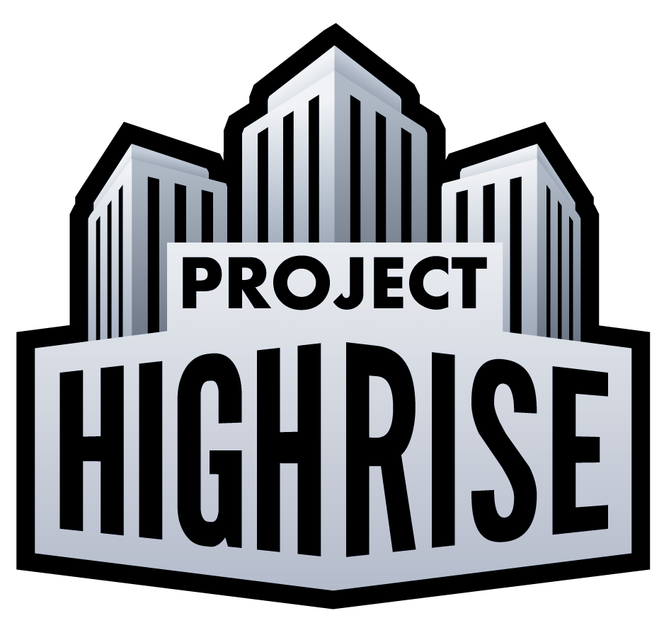

**Project Highrise prepares to tower over the App Store and Google Play**

*Smash hit PC skyscraper construction and management sim arrives on iPad and Android tablets*

Hamburg, Germany – 12 April 2018. Game publisher and developer Kalypso Media along with developer SomaSim, today announced the launch of smash hit PC skyscraper construction sim *Project Highrise* on iPad and Android tablets. Delivering sky high thrills to armchair architects around the world, *Project Highrise* has been extensively redesigned for touchscreen devices.

Playing as both architect and developer in *Project Highrise*, your job is to build world-famous skyscrapers that will be the envy of the entire city, masterpieces of art and engineering. But a skyscraper is more than just steel and glass; it’s an intricate ecosystem, full of people that live and work in the building. They become a complex machine that needs your steady hand to keep it running smoothly and efficiently.

From the moment you break ground, every decision rests with you. As the architect, you must coordinate the construction of everything - every wall and wire, every office and apartment. As the building owner, you must keep your tenants happy - and pay rent on time. As a savvy developer, you must keep an eye on the bottom line and invest in the future. Succeed, and you will reap the rewards of a prestigious address where everyone will clamour to live and work. Fail, and you will watch tenants leave in disgust, taking their business elsewhere and leaving your reputation in tatters.

Will you create an exclusive office highrise that attracts business leaders from around the world? Will you construct luxury apartments in the sky, penthouses for the elite and playgrounds for the famous? Perhaps greed will get the better of you, and you’ll build a tenement building that trades tenant happiness for loads of cash? All these choices and more are yours. Success is entirely in your hands.

Download the game from the App Store:

<http://itunes.apple.com/app/id1277095117>

Download the game from the Google Play Store:

<http://play.google.com/store/apps/details?id=com.kalypsomedia.projecthighrise>

**Features:**

· Deep and complex simulation of a modern skyscraper.

· Huge variety of tenants with their own unique characteristics, from restaurants, to offices, retail stores, or residential apartments.

· Open sandbox play with several difficulty levels and starting conditions allowing you to build your dream skyscraper towering above the surrounding city.

· Campaign mode that tests your skill at building a successful highrise in challenging scenarios.

· Test your management mettle by keeping up with your buildings diverse population and their ever-increasing demands.

· Hire specialized consultants to increase your building's curb appeal, operational efficiency, and pull with city hall.

Sold as a premium-priced title, *Project Highrise* comes to tablets complete with hours of challenging gameplay. Players also have the option to purchase bonus expansion packs introducing new luxury apartments, retail options, office types, scenarios and more to broaden the experience.

Project Highrise is available globally for iPad priced at £3,99/ $3,99/ 4,49 Euros

Project Highrise is also available globally for Android tablets priced at £3,99/ $3,99/ 4,49 Euros.

-------Ends ---------

**Notes to Editors**

Access the press kit containing the release and visuals here: <https://drive.google.com/drive/folders/19z5Rqz0evzshGDBU95oXfmjOTHqJyz28?usp=sharing>

For more information please contact:

Theo Tsangaris - theo@biggamesmachine.com

TEL: +44 (0) 203 637 4244

Big Games Machine - <http://www.biggamesmachine.com>

**About The Kalypso Media Group**

Celebrating its 12th year in the video games industry, the Kalypso Media Group is a privately owned, global, independent developer, marketer and publisher of interactive entertainment software with close to 100 employees worldwide, operating from seven offices across Germany, the United Kingdom and the United States. Kalypso Media has also established a digital-first label called “Kasedo Games” and enjoys very strong global digital distribution through its Kalypso Media Digital subsidiary. Furthermore, the group owns two development studios – Realmforge and Gaming Minds– to secure a constant supply of high quality games, and works with multiple leading independent developers. In 2015, Kalypso Media Mobile was founded in Hamburg, Germany, to deliver great games for mobile devices.

Kalypso Media‘s titles include the critically acclaimed “Tropico” series, strong strategy game franchises like “Dungeons”, “Port Royale” and “Sudden Strike”, as well as action RPG games such as “Vikings – Wolves of Midgard”, among others. For 2018, “Railway Empire”, “Shadows: Awakening” and “Tropico 6” have been announced for all major platforms (PC, Xbox One, PS4), along with "Sudden Strike 4: European Battlefields Edition" for Xbox One. Moreover, Kasedo Games has signed “Rise of Industry” for digital distribution and Kalypso Mobile recently released "The Official BBC Earth Quiz" and “Ski Jumping Pro.”

More information about the Kalypso Media Group is available at: <http://www.kalypsomedia.com>