**Tilted: A Tale of Refraction**

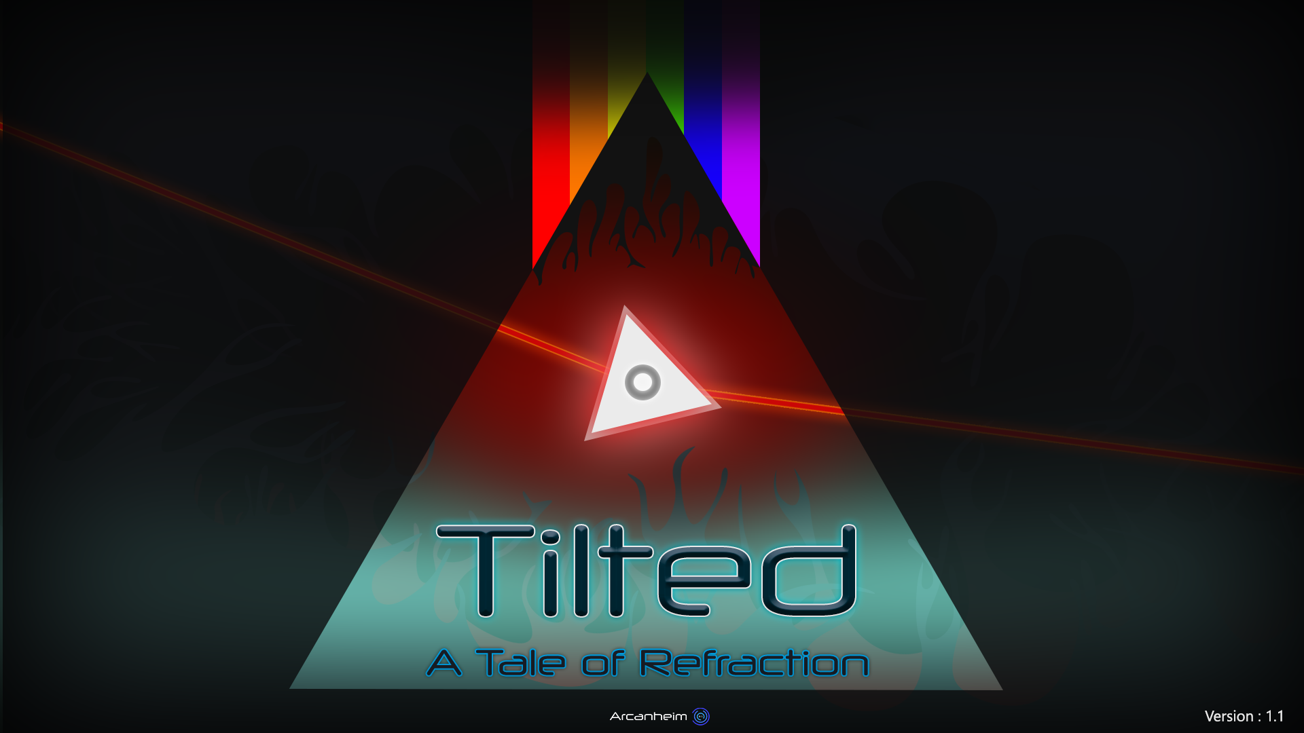

MON 22 MAY 2017 6:30AM GMT/ 2:30AM EST/ 12:00AM IST

Friends ,gamers, countrymen, lend me your thumbs for a tilting experience into the crystalline depths of *Lumenos*!

*April 8, 2017 - Pune, India* - Arcanheim Softworks has announced the launch of it’s first game, ”Tilted: A Tale of Refraction” for Android.

Are you tired of the same kind of repetitive gameplay in today’s games?

Are you looking for something new? Something different?

*Tilted* is an exciting 2D Physics Puzzle game for iOS and Android that combines exploration and survival with real time physics. The game will test the players’ reflexes, skills, timing and high school physics!

*You play as Prizzo, an ancient spacefaring prism who is on a quest to save the universe by avoiding deadly hazards and refracting lasers. Prizzo must repel the darkness parasite and bring back the light to Lumenos. Refract and rotate your way through crystalline caverns and solve puzzles by using the laws of reflection and refraction, to complete over fifteen deadly levels before time runs out.*

**The objective is simple:** Do not die. Activate the portal. Go through.

The game supports a touch control system, which is intuitive and easy to understand but hard to master. The developer Arcanheim Softworks, has ambitions to raise the standards of mobile gaming by introducing fresh and very challenging gameplay. The world of *Tilted* has beautifully handcrafted environments which are enthralling to explore, hard to survive in and packed with secrets to find.

Tilted: A Tale of Refraction is currently available (and completely FREE) on the Google Play Store  
<https://play.google.com/store/apps/details?id=com.arcanheim.Tilted>

Coming to the App Store very soon. TestFlight build now available on request

###

***Press Kit*** with screenshots and video trailer available at [www.arcanheim.com/press](http://www.arcanheim.com/press)

***Contact information and Links:***

Email - [ask@arcanheim.com](mailto:ask@arcanheim.com)

Website - [www.arcanheim.com](http://www.arcanheim.com)

Facebook - [www.facebook.com/arcanheim](http://www.facebook.com/arcanheim)

Twitter - [@arcanheim](https://twitter.com/arcanheim)

Instagram - [@arcanheim](https://www.instagram.com/arcanheim)