***Press release***For immediate release***

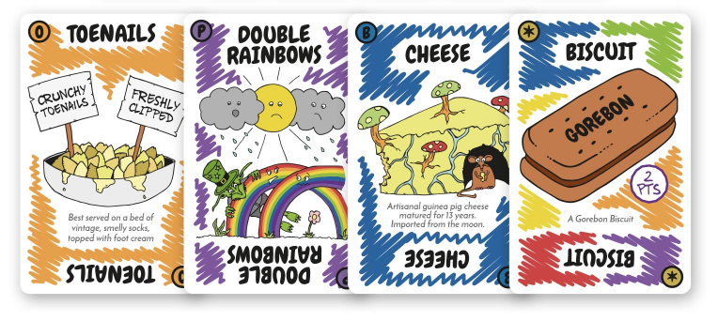
Gobblin’ Goblins - the brand new ‘Orrible Eat-A-Thon Card Game launches on Kickstarter this Halloween

The makers behind a brand new card game have launched a crowdfunder to help share their gross game with people across the UK and beyond.

Gobblin’ Goblins has launched with an event in Bournemouth (UK) this month and a Kickstarter campaign (link: https://www.kickstarter.com/projects/2060696175/gobblin-goblins-the-orrible-eat-a-thon-card-game) to coincide with Halloween.

With pledges already pouring in, the Gobblin’ Goblins team are already halfway towards their ambitious target of £5,500 which would enable the game to go in production and get distributed to retailers and gamers. The campaign ends on November 26, 2017.

Pledges start at just £8 with some big rewards on offer for those willing to pledge up to £150, including yourself immortalised as a Gobblin’ Goblins character by the game’s artist and illustrator Dan Prowse.

This delightfully disgusting game involves goblins stuffing themselves with mud pies, slimey slugs, toenails, bogeys and many more outrageously gross foods. With 12 characters, including Lady Bunions and Murky Splatters the game provides hours of entertainment.

A game for kids and adults alike, with a player count of 2-12 players, meaning it’s the perfect family game. The fun artwork includes plenty of jokes which older generations will appreciate as well as toddler-level humour. The game mechanics are nice and simple and provide hours of fun.

Gobblin’ Goblins is the brainchild of game-fanatic and designer Angela Dickens, who says: “We had a ton of fun coming up with all the gross and sometimes even improbable things the goblins could eat. A lot of thought went into the action cards too, making sure they worked with the theme. The food poisoning card would definitely be my favourite out of those, the illustration by our artist, Dan Prowse, is just brilliant. We’re so excited to share this game with the world.”

Ends

Notes to Editors:

For more information, interviews, photos or a review copy, please contact Angela Dickens
// email: info@gobblingoblins.com // tel: +44 (0) 7817 856311

A set of press images is available for download here: http://gobblingoblins.com/media/media.zip

Game Info
• Players: 2 - 12
• Ages: 8 - 80
• Time: 20 - 30 minutes
• Theme: Gross Gourmet, Goblins
• Game Type: Light, Strategic, Set Collection, Take That!
• Family Friendly

About the Gobblin’ Goblins makers
Angela Dickens (Designer) and Dan Prowse (Illustrator) are two friends who are based in Bournemouth, Dorset. This is their debut game and they’re looking to make their mark in the board game world. Their aim is to make fun, accessible games with humorous themes and put quality of product before profit margins.

