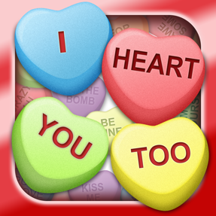
I Heart You Too

Hairy Monster Studios Releases ‘I Heart You Too’ available on the Apple App Store and the Google Play Store

Introducing the world's first match three game that allows you to send virtual gifts to your Facebook and Twitter friends.

Pewaukee, Wisconsin – February 8, 2016 – Available today, the mobile game I Heart You Too, offers classic match three fun with an innovative twist, to IPhone and Android phone users.
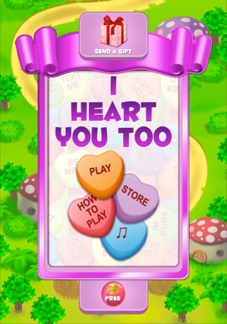
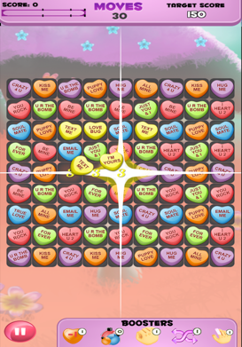
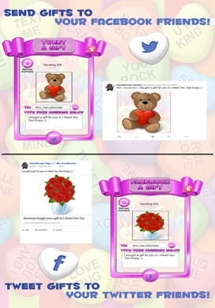
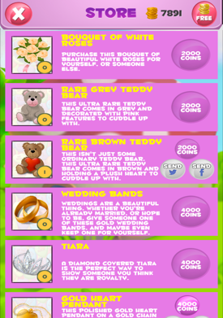
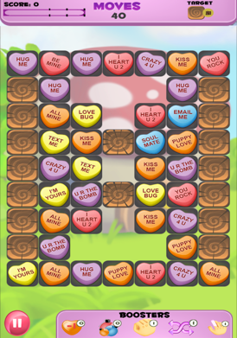
I Heart You Too is the world's first match three game that allows you to send virtual gifts to your Facebook and Twitter friends. Choose from over 60 unique gifts, type a personalized message, then select what Facebook or Twitter friend the gift goes to! Earn coins by beating levels to spend on gifts, boosters and more!

With 100 addictive, and carefully designed match three levels, and 6 exciting level types (Score, Timed, Glass, Sugar Drop, Block, and Color) you're guaranteed to be entertained for hours on end. If you want to have a blast while making someone's day, come on and play I Heart You Too, today!

I Heart You Too is completely free to play, but there are optional in-app purchases available.

Features:
- 100 Addictive Levels
- 6 Different Level Types
- Earn Coins to Purchase Gifts and Boosters
- Send Gifts to Facebook and Twitter Friends!
- Over 60 Unique Gifts to Choose from

Based in Pewaukee, Wisconsin, Hairy Monster Studios has been making games and apps for the iPhone, iPod touch, iPad. Android, and PC for more than eleven years.

