**Description**

Abbeys Flight is a bee flight sim, available now on all iOS devices.

Based around 12 lush real world environments. Where you hunt for vital supplies of pollen, water and tree sap to bring back to the hive. While avoiding natural hazards like: hornets, infection and rain (a scary thing if your the same size as a bee).

Once you've competed each of the flying levels you get the chance to: practice your flower landing skills, perform a waggle dance and try to keep the hive warm by shaking your tail.

**Concept**

To create an ethical game which brings awareness to a needy cause, and hopefully raises funds for bee conservation projects round the world.

**Key Features:**

* 12 Beautiful real world landscapes to explore.
* Learn more about these fascinating creatures through play.
* 3 Types of bonus level: Waggle dance, Practice landing on flowers, Keep the hive warm.
* Real world hazards like: hornets and infections.

**Release Date**: Available Now

**Platforms**: iPhone & iPad

**Price**: Free, No Ads.

**Contact Information**

**App Store Link:** <https://appsto.re/gb/L_YP5.i>

**Email**: [stuart.mclean@AbbeysFlight.com](mailto:stuartmclean1502@yahoo.co.uk)

**Twitter**: @StuartMclean6

**Facebook**: <https://www.facebook.com/groups/335097816680785/>

**Trailer**: https://vimeo.com/209461803

**IndieDB**: <http://www.indiedb.com/games/abbeys-flight>

**A Brief History**

The idea for this came while out running through the countryside near to my work, I wanted to capture that same feeling in a game, but running doesn't really translate well into game play. So I began to look at what else would have a similar experience and watched a bee fly past and thought it might make for an interesting game (it was only later I discovered the bee would be far quicker). A lot of the levels have a similar feel to my regular running route. Others have drawn inspiration from my bee keeping friends Graham and Jo.

As a developer having a focus to work towards I found pushes you into learning new skills which you might otherwise miss. I've learnt a huge amount just by experimentation from: occlusion culling to light mapping to performance optimisation. Keeping that focus through the development cycle helps you be objective about your work and accept that sometimes something it's just not working and you should rework it till its right. Creating rain was one of those issues. Initially it was the correct scale to the bee, but you knew it looked wrong, so was changed to be a more human scaled rain.

I'm using the Unity game engine to develop Abbey's Flight, which is incredible. It's only taken me 8 months to get from installing Unity to the point I can feel proud to show off what i’ve developed to other people. Something I never thought was possible.

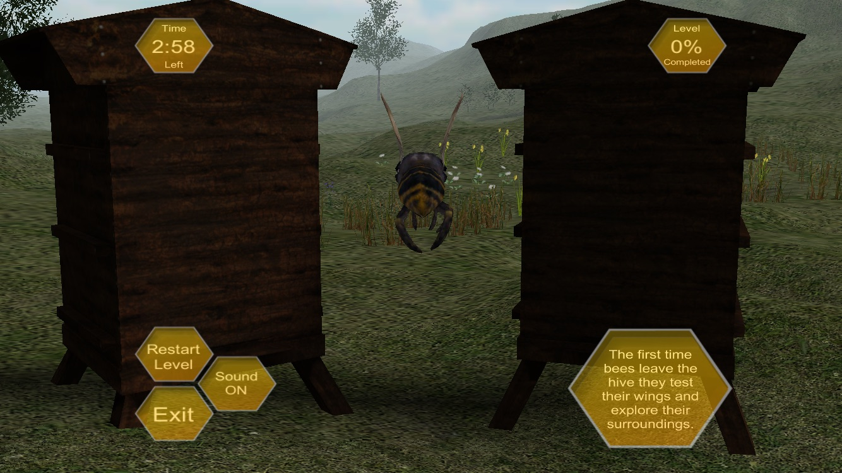

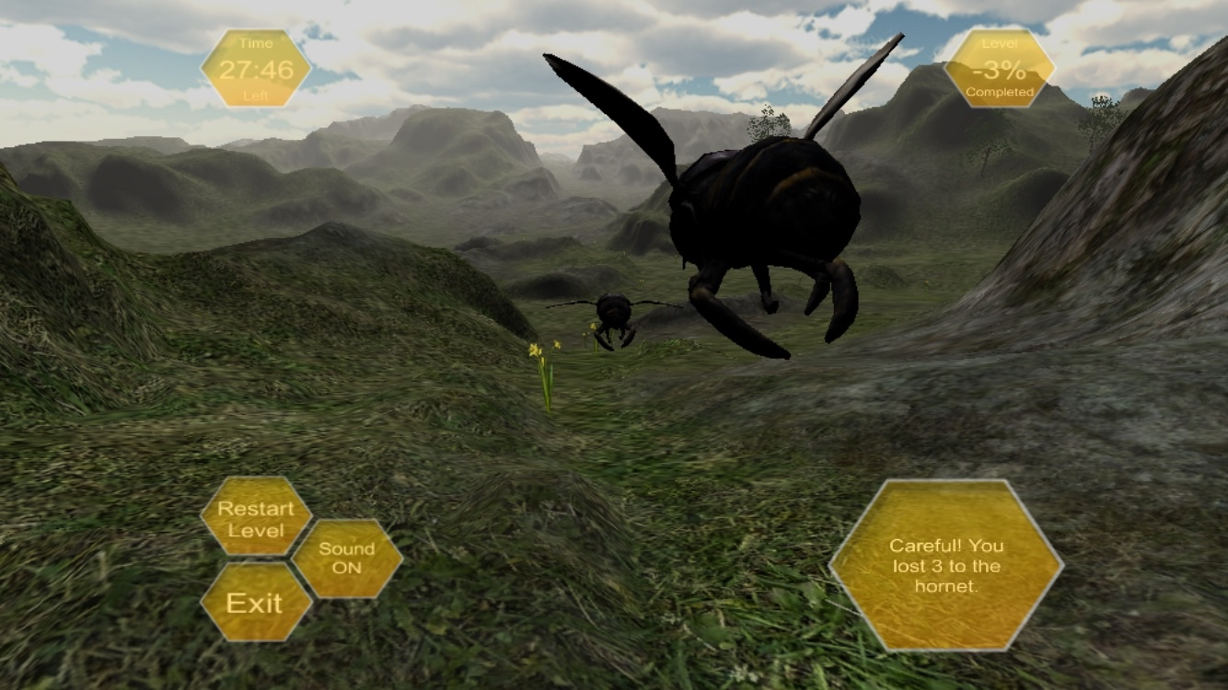

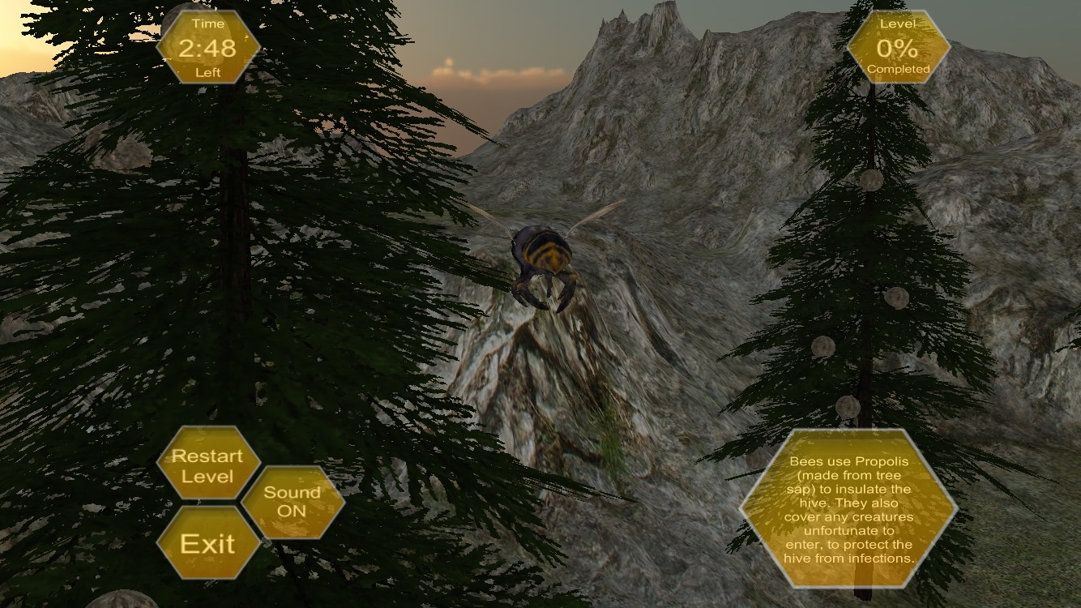

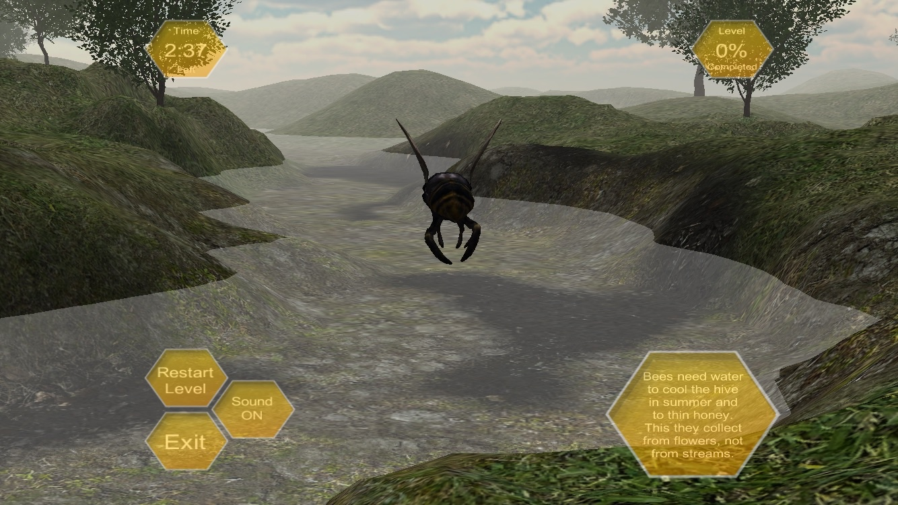

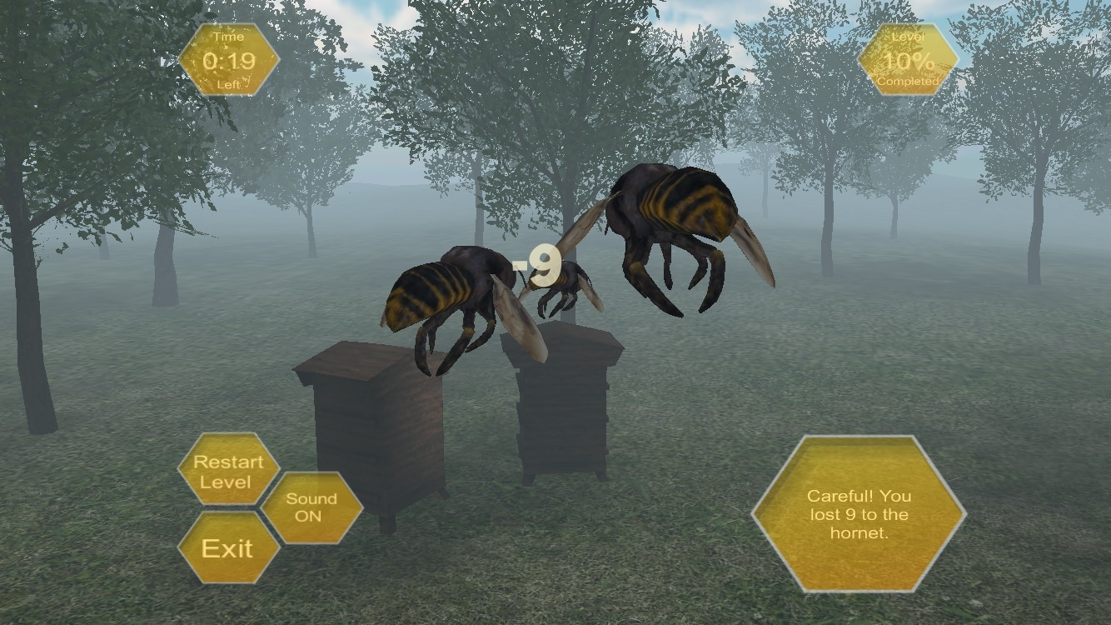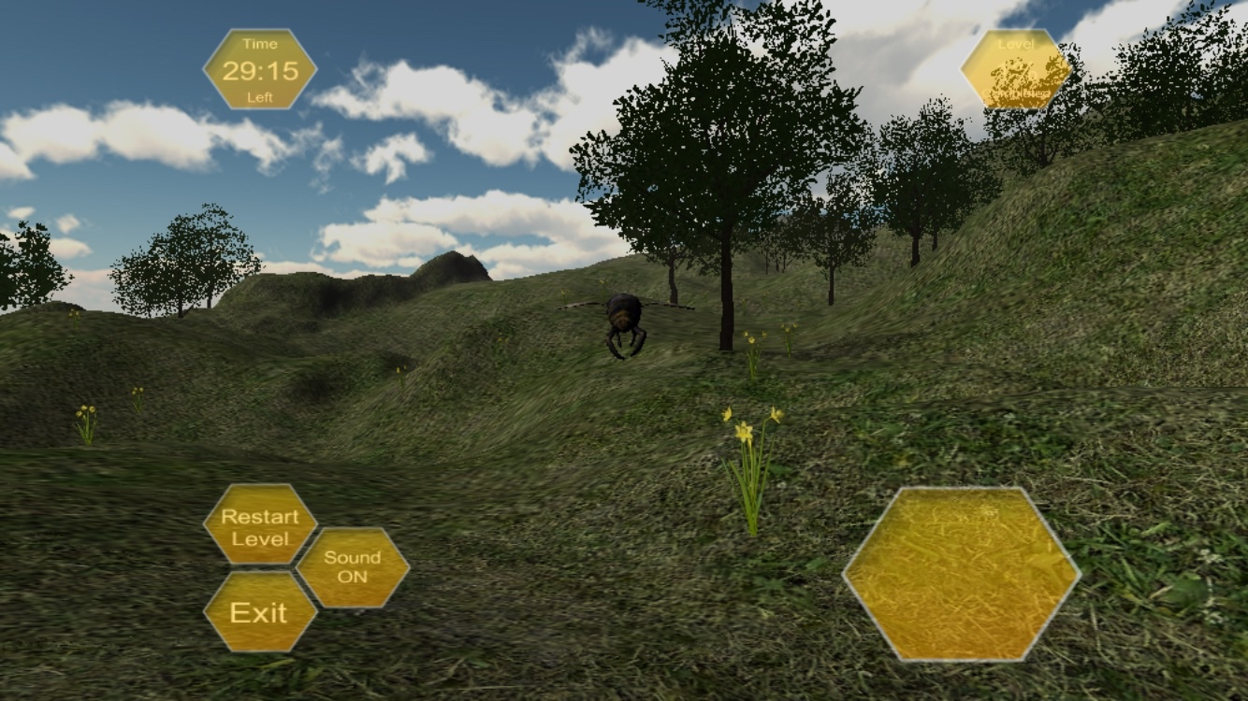

Bonus Levels